**Project Proposal**

**DEVELOPMENT A WEBSITE FOR VIETNAMESE NOVEL READER AND WRITER**

**Student Name:** Nguyen Phuong Thuy

**Student Identification:** GCH17470

**Supervisor:** Doan Trung Tung

**COMP1682:** Project

**Date:**

Table of Contents

Table of figures 4

1. Overview 5

2. Aims 6

3. Objectives 6

3.1. Objective 1: Gather user requirements 6

3.1.2 Activities 6

3.1.3 Deliverables 7

3.2 Objective 2: Determine the technology to be used 7

3.2.1 Activities 7

3.2.2 Deliverables 7

3.3 Objective 3: Create project development planning 7

3.3.1 Activities 7

3.3.2 Deliverables 7

3.4 Objective 4: Analysis of user requirements and Design 8

3.4.1 Activities 8

3.4.2 Deliverables 8

3.5 Objective 5: Develop website 8

3.5.1 Activities 8

3.5.2 Deliverables 8

3.6 Objective 6: Testing 8

3.6.1 Activities 8

3.6.2 Deliverables 8

3.7 Objective 7: Evaluate the website and complete the final report 9

3.7.1 Activities 9

3.7.2 Deliverables 9

4. Legal, Social, Ethical and Professional 9

4.1 Legal 9

4.2 Social 10

4.3 Ethical 10

4.4 Professional 11

5. Project plan 12

6. Initial references 13

# Table of figures

Figure 1: Plan of the project 12

# 1. Overview

Currently, the community of lovers of novels in Vietnam is thriving. In the community of novels lovers, in addition to a large group of readers, there is also a large part of those who have the need and ability to compose. They often share their works via some social networks such as: Facebook, personal blog, or some website. There are many websites and mobile apps in this area on the market, but they often focus only on satisfying the reading needs of readers. The project that I plan to do is to build a website for the community of novel readers and writers in Vietnam. This website allows users to edit and publish their works or read stories by chapter. In addition, in each chapter, the author can ask readers to pay a fee in the form of coins to be able to read the story. Coins can be redeemed from a deposit or receive a free amount of coins by logging into the website and taking attendance daily. Users can exchange coins to receive money when they reach a certain amount of coins.

To build this application, I can use popular programming languages to develop websites such as: HTML, Css, Java Script, PHP, C#, .... and corresponding frameworks and libraries of those languages. Besides that, I also need to use databases like MySQL, PostgreSQL, SQLite, ... to store data of the website.

The website will include the following features:

* Allows users to read and edit novels. Users can only edit each story chapter on the website and up load them.
* Allows users to recharge and receive coins converted at a specified rate.

In addition, this website will not include the following:

* Support users to compose and read comics
* Allow users to post edited content files on other software or websites such as Microsoft Words, Google docs, Notepad, ....
* Responsible for the copyright for stories posted by users.

**Key phases:** Front-end, back-end, website to read novels, website to publish novels, online payment

# 2. Aims

The aim is to develop a website dedicated to the community of novel lovers in Vietnam. This site allows users to read and write novels by chapter. In addition, the authors can charge other users to read some of their stories by paying coins and users can get coins by recharging. Once a certain amount of coins is reached, authors can receive redeemable money from the number of coins in their wallet.

In order to develop this website, I need to research and learn a lot of things. The first issue to determine is what the functions and requirements that readers and writers of the novel need and want to use at a web site intended for them. To identify these features, I need to access websites, mobile applications that allow users to read novels or allow authors to post their stories are available on the market in order to gather experiences about those websites and applications and the opportunity to communicate with other users about the features they want to. From there, I was able to identify the features needed for the website. After determining the necessary features, what I need to do next is to research articles and documents related to web sites about the field of novel reading available on the market, learn and compare web programming languages: C#, Node Js, PHP, Java, Javascript, python, ... to find out the appropriate programming language and libraries, frameworks corresponding to programming languages there. Similar to the database, I also need to learn and compare databases like MySQL, SQLite, ... to choose the right database to store a huge amount of data of my website. Then I need to develop and test the features, and in the process I also have to identify possible problems with a website that allows users to read, compose stories, load and receive money from the website and find directions and ways to deal with them. These issues can be: account security issues, content copyright issues, censorship of content uploaded to the website to avoid malicious code, content that violates the law or social ethics, secure the user's payment information, ensure the stable operation of the website when many users access at the same time, ...

# 3. Objectives

## 3.1. Objective 1: Gather user requirements

### 3.1.2 Activities

* Research websites and applications that allow reading novels and up load novels existing in the market
* Use these similar products, evaluate them and survey other users within those websites to see what features they expect to use.

### 3.1.3 Deliverables

* Synthesizing and listing existing features on those websites and applications, features that the user wants to use.
* Selecting the features that will be available in the website to meet the needs of users and have a competitive advantage over existing websites.

## 3.2 Objective 2: Determine the technology to be used

### 3.2.1 Activities

* Study on web programming languages: HTML, Css, JavaScript, PHP, Java, Python, ... and the corresponding libraries and frameworks.
* Study on database programming languages: MysQL, SQLite, PostgreSQL, ...

### 3.2.2 Deliverables

* A report about analyzing, summarizing, comparing web programming languages and identifying the programming languages to be used.
* A report that analyzes, aggregates, and compares the database programming languages and identifies the database programming languages to be used.

## 3.3 Objective 3: Create project development planning

### 3.3.1 Activities

* Determine the time to design systems, databases, interfaces for the website for Vietnamese novel reader and writer
* Determine the time to implement interfaces and features for this website
* Determine the test website time
* Determine the completion time of relevant documents: website performance assessment report, final report

### 3.3.2 Deliverables

* A Gantt chart of website development plan for Vietnamese novel writers and readers

## 3.4 Objective 4: Analysis of user requirements and Design

### 3.4.1 Activities

* Define the user of the website and the features they are using on website for novel writers and readers (create Use case diagram for this website)
* Create Class diagram of the website for novel writers and readers
* Create database of the website for novel writers and readers
* Create graphical interfaces of the website for novel writers and readers

### 3.4.2 Deliverables

* Use case diagram
* Class diagram
* Database
* Blueprints of the user interfaces

## 3.5 Objective 5: Develop website

### 3.5.1 Activities

* Implement interfaces
* Implement features

### 3.5.2 Deliverables

* Product: Website for reading and composing novels for the Vietnamese community

## 3.6 Objective 6: Testing

### 3.6.1 Activities

* Create Test case
* Test features and interface according to test case

### 3.6.2 Deliverables

* Documentation of Test cases
* Test results
* Test results report

## 3.7 Objective 7: Evaluate the website and complete the final report

### 3.7.1 Activities

* Analyze and evaluate the strengths and weaknesses of the website and find ways to overcome them
* Write the final report

### 3.7.2 Deliverables

* The report evaluates the website's performance and future development plans
* The final report

# 4. Legal, Social, Ethical and Professional

## 4.1 Legal

The content of this website is developed by user contributions, so it is difficult to control the issue of copyright of the content of the works posted. At the same time during the development of this website for demo purposes, the developer may use a number of stories, images, ... from other websites and applications. Therefore, this website is completely at risk of facing copyright issues. To solve the problem of copyright for the content in the construction of the website, the developer can use images, story content from open sources, or contact the owner of the content directly to request to get permission to use the content for other purposes or or create the images, content that needs to be used. As for the copyright issue of user-posted works, the solution will be to ask the user to take responsibility for the copyright for the content of the work they up load and when a work has proven to be copyright violation and required removal, the administrator will remove the work from the website.

The second legal issue that the website will likely face is the protection of the safety of users' personal information and online transactions information. These are sensitive information that is very attractive to hackers who can attack websites to steal this information. Therefore, sensitive personal information such as passwords and phone numbers need to be encrypted before being saved to the database. Online transactions will be through a third party that specializes in providing reputable online payment solutions in the market such as VNPay, OnePay, Momo, Paypal, ... to bring the highest convenience and security to user.

## 4.2 Social

This website is developed towards the community of novel lovers in Vietnam. Since this is a community with a large number of members, the development of this website can also have some influence on society.

On the positive side, this website can encourage users' writing abilities as this is where users can unleash their creativity, practice their writing skills, hone their vocabulary and share perspectives, thoughts, emotions, morality, lifestyle, culture through their works freely. At the same time, they can receive the attention, welcome, suggestions and support from a large number of people with common interests and from there, tthey can gain the motivation and experience to develop the creative ability in general and using language in particular. In addition, the money that authors can get from the coins users pay to read their works can also be another source of motivation for them to develop themselves, even from the people who like to write stories become professional journalists or writers. Secondly, besides stories written by Vietnamese authors, novels lovers in Vietnam cannot always ignore novels posted on major Chinese websites and some of novels of writers come from other countries. They are written in the predominantly Chinese and English languages, so someone needs to translate them. Therefore, in addition to promoting the ability to compose, this website also creates opportunities for users to hone and improve their ability to translate foreign languages.

Along with these positive effects, the development of this website can also cause negative effects on society. Firstly, the works are posted on the website can cause users to spend a lot of time using electronic devices such as computers, smartphones to access and read them. If they do not control the time and proper use of these electronic devices, this could have adverse effects on their health. Secondly, the majority of members of the community who love novels are between the ages of 13-25. At this teenage age, their thoughts, thoughts and behaviors are easily affected by stories that are too violent, negative, or content that is too dreamy, unrealistic. maybe in swordplay, horror, ... They may have violent, angry behavior or apply behaviors like some characters in the story to real life.

## 4.3 Ethical

During the operation, the website may collect some personal information of users such as full name, gender, address, email address, …. This information is only used for the purpose of analysis and research so that the developer has appropriate updates to the website. User personal information will not be disclosed to third parties.

In addition, the works posted on the website will be stored on the database, all updates and modifications to these works will be done by the account that owns these works. Administrators only have the right to remove works in case of copyright infringement and this work has been requested to remove. In this case, the account that owns this work will be notified via the registered email.

During the development of the website, the developer can take the content from other websites and applications such as website introduction content, general rules, ..., this can be considered as plagiarism, which is the thing developers should not be acquired. Instead, developers can build their own introductory content and rules to create a highlight for the website and impress users.

## 4.4 Professional

Firstly, in the process of developing a project in particular and a website in general, project planning and ensuring the completion of the project schedule in accordance with the set plan is an indispensable factor to evaluate the professionalism. At the beginning of the project, the developer should set a plan, time to complete and organize the work in a clear, specific order and regularly monitor and update the progress of the project every week. The project planning and management support tools that developers can use are: Microsoft Project, Trello, ….

Secondly, website needs to be thoroughly tested accorrding to the test cases before being put into operation. And the process of design, development, and testing all need documents to serve the process of upgrading systems, transferring technology, ….

Finally, one of the purposes of a website is to make it easy for users to find and access, thus optimizing search rankings on search engine sites like Google. Therefore, when building website interface, developers need to apply ways to optimize search engine (Search Engine Optimization - SEO) such as using heading tags (h1, h2, h3, ...), optimizing meta description tags, …. .

# 5. Project plan

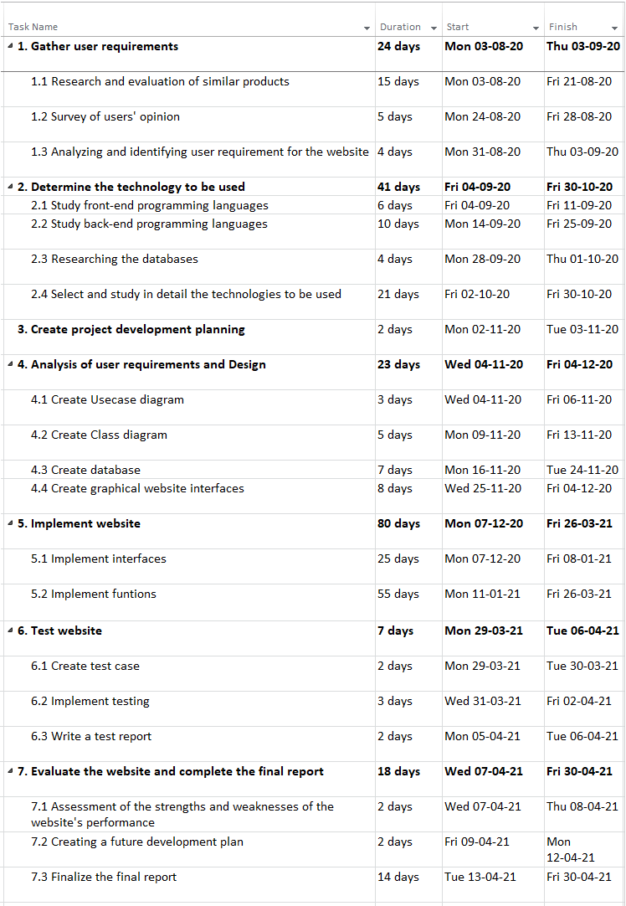

Figure : Plan of the project

# 6. Initial references

administrators, S., 2019. *Stackoverflow.* [Online]   
Available at: https://insights.stackoverflow.com/survey/2019#technology  
[Accessed 16 September 2020].

Dayley, B., 2014. *Node.js, MongoDB, and AngularJS Web Development.* The United States: Addison-Wesley Professional.

Hai Wang, Shouhong Wang, 2014. *Programming Languages for MIS: Concepts and Practice.* s.l.:CRC Press.

Kreibich, J. A., 2010. *Using SQLite: Small. Fast. Reliable. Choose Any Three..* 1st ed. The United States: O'Reilly Media, Inc..

Mishra, A., 2014. Critical Comparison of PHP and ASP .NET for Web Development. *International Journal of Scientific & Technology Research*, *3*(7), pp.331-333.

Newman, C., 2005. *SQLite.* s.l.:Sams.

Powers, D., 2006. *Foundation PHP 5 for Flash.* The United States: Apress.

Rasmus Lerdorf, Kevin Tatroe, Bob Kaehms, Ric McGredy, 2002. *Programming PHP.* 1st ed. The United States: O'Reilly Media, Inc..

Smith, D. and Ali, A., 2014. ASSESSING MARKET DEMAND FOR WEB PROGRAMMING LANGUAGES/TECHNOLOGIES. *Issues in Information Systems*, *15*(2).